


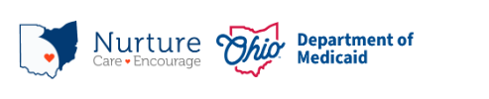
PRAF 2.0 NurtureOhio Interface:
Managed Care Organizations
User Guide

Contents
Welcome New Users! 4
What is NurtureOhio? 4
NurtureOhio Features 4
Who Should Use NurtureOhio? 5
What is a PRAF? 5
What is an ROP? 5
Benefits of Using NurtureOhio to Submit Pregnancy Notifications: 5
User Types 6
How to Obtain Access to NurtureOhio as a first-time MCO and Secondary MCO User 6
How to Log into NurtureOhio 7
Forgotten Username or Password 8
NurtureOhio Initial Profile Setup 9
Welcome Screen 9
Updating User Information (the Edit User Profile Screen) 10
How to Submit a Report of Pregnancy (ROP) 11
Add Patient Information 12
Patient Validation 12
Patient Validation Fields 12
ROP Form 18
Processing Referrals 21
Accessing Referrals 21
Referral Reporting Screen 22
Adding Additional Concerns 27
Exporting 31
Exporting Referrals 31
Exporting ROPs 31
Exporting PRAFs 32
Log Out 33
Help Desk and User Support 33
Help Form 33
Maintenance and System Outages 34
Appendix A 35
About NurtureOhio Features 35
Shareable Data Entry 35
Same-Day Pregnancy Notification 35
Ability to Retrieve and Save Previously Entered Forms 0

Welcome New Users!
This guide will help you navigate the NurtureOhio website. Some of the key items provided are:
- Definitions of Perinatal Risk Assessment Form (PRAF) and Report of Pregnancy (ROP) related topics
- Step by step guidance on getting access to and logging into the NurtureOhio system
- Step by step guidance on member referrals process
- Features of NurtureOhio
- Help with troubleshooting
- Additional tips and resources

What is NurtureOhio?
NurtureOhio was developed in 2016, in partnership with the Ohio Perinatal Quality Collaborative, the Ohio Department of Health, 23 Medicaid Maternal and Fetal Medicine providers, and the five Medicaid Managed Care Organizations (MCOs) to standardize pregnancy notification and decrease the risk of preterm birth. Through continued spread, the project has since grown beyond the progesterone quality improvement project, and the NurtureOhio web-based system has become the Ohio Department of Medicaid’s preferred method for notification of pregnancy and the postpartum period for all Medicaid-insured individuals across the state.

NurtureOhio is a web-based system that stores and shares information about perinatal risks and health-related social needs (HRSNs). This information is collected using the electronic Perinatal Risk Assessment Form (PRAF 2.0) and the Report of Pregnancy (ROP). Once a user submits either the PRAF 2.0 or ROP in NurtureOhio, the data is seamlessly transmitted to Ohio Medicaid’s eligibility system to ensure maintenance of Medicaid coverage, the Ohio Department of Health (ODH) for connection to the Women and Infant Nutrition Program (WIC), the Ohio Department of Children and Youth (DCY) for evidence-based Home Visiting, and the individual’s County Department of Job and Family Services and Managed Care Organization (MCO) for resources and identified needs.

NurtureOhio is used to notify the Ohio Department of Medicaid and key stakeholders of pregnancy and the start of the postpartum period for all Medicaid-insured individuals for eligibility maintenance and care coordination. Through the PRAF and ROP, NurtureOhio transmits the minimum information needed about Medicaid individuals’ pregnancy and postpartum information to the appropriate stakeholders to ensure their needs are met.

NurtureOhio Features
- Shareable Data Entry
- One Time Data Entry of Practice and Provider Information
- Same-Day Pregnancy Notification
- Ability to Retrieve and Save Previously Entered Forms
- Ability to Export CSV files of submitted PRAFs
More information on these features can be found in Appendix A.

Who Should Use NurtureOhio?
- Clinical obstetrical providers should submit a Perinatal Risk Assessment Form (PRAF) on behalf of their patients.
- Clinical non-obstetrical providers, such as primary care providers, emergency department providers, local health department clinics, etc. (when able to positively confirm the individual’s pregnancy) should submit a Report of Pregnancy (ROP).
- Community Based Organizations (CBO) and Managed Care Organizations (MCO) should also submit an ROP at the first identification of a positive pregnancy.
- Managed Care Organizations (MCOs) and County Department of Jobs and Family Services (CDJFS) to assist with resource connection.

What is a PRAF?
The Perinatal Risk Assessment Form (PRAF) is an assessment that is intended for completion and submission by all obstetrical providers at the Medicaid patient's first prenatal visit, the start of the postpartum period, and whenever there are changes in the patient's perinatal medical, social risk factors or needs. The PRAF collects perinatal risk and health-related social needs. The PRAF replaces the ODM 03535 form. The web-based version of the Perinatal Risk Assessment (PRAF 2.0) is ODM’s preferred method for submission.

What is an ROP?
The purpose of the Report of Pregnancy (ROP) form is to capture a Medicaid individual’s pregnancy as soon as possible to assist with eligibility and care coordination. ROPs are intended for submission at the first report of pregnancy. The ROP can be submitted by non-obstetrical Medicaid providers, Medicaid MCOs, and CBOs. For example, if a patient is on a telehealth visit with their primary care physician and reports being pregnant, an ROP should be submitted on behalf of the patient. An additional example would be if a patient is seen at the emergency department or a local health department and is determined to be pregnant, an ROP should be submitted on behalf of the patient. The goal is to connect the individual to obstetrical care and other services and ensure coverage throughout pregnancy and the postpartum period to optimize health care access and health outcomes for the mother and infant. Again, the ROP is only intended for submission by non-obstetrical Medicaid providers, Medicaid MCOs, Doulas, and CBOs.

Benefits of Using NurtureOhio to Submit Pregnancy Notifications:
- Updating pregnancy details in Ohio’s Medicaid Eligibility System to prevent loss of Medicaid coverage during pregnancy and postpartum period.
- MCOs notification of potential members for care coordination and incentive programs to provide support and resources during pregnancy and the postpartum period.
- Enables County Department of Job and Family Services (CDJFS) users to verify that pregnancies are added to the Ohio Benefits system and coordinate care via referrals.
- Timely referrals to the Ohio Department of Health’s (ODH) Special Supplemental Nutrition Program for Women, Infants, and Children (WIC).
- Referrals to The Ohio Department of Children and Youth’s (DCY)Home Visiting Central Intake platform.

User Types
Users are classified into six different user types which impact what views they have access to and how they enter information in the NurtureOhio system. For the purposes of NurtureOhio, ODM defines the following user types:
- Practice users as those users associated with a practice that provides obstetric services.
- MCOs as those users affiliated with ODM’s contracted Managed Care Organizations.
- Non-OBGYN are users associated with a clinical practice that does not provide obstetric services but can confirm an individual’s pregnancy via a positive pregnancy screening such as primary care, emergency department, urgent care, community health centers, community clinics, etc., and as those users identified by ODM as doulas.
- Secondary MCOs as those users affiliated with ODMs contracted Managed Care Organizations as secondary MCOs.
- OEI Community Based Organizations (CBO) and CBO Lead Entities as those users from organizations identified by the Ohio Department of Medicaid as Ohio Equity Institute Lead Infant Mortality Entities and their corresponding Community Based Organizations.
- County Department of Job and Family Services Healthchek/PRS workers as those users specializing in pregnancy related services for CDJFS office.

How to Obtain Access to NurtureOhio as a first-time MCO and Secondary MCO User
- MCOs must designate a lead individual to submit requests for new users using the NurtureOhio Microsoft Access Request Form. The link to the form can be obtained by sending a request to MomsAndBabies@medicaid.ohio.gov.
- The lead will complete the Microsoft form and submit it.
- Once the new user is added, the lead and the new user will be notified via email.
- When the new user logs into NurtureOhio for the first time, they will need to choose “Internal” from the dropdown box, enter their email as the username and then click “Forgot Password?” to set up their password for the first time.
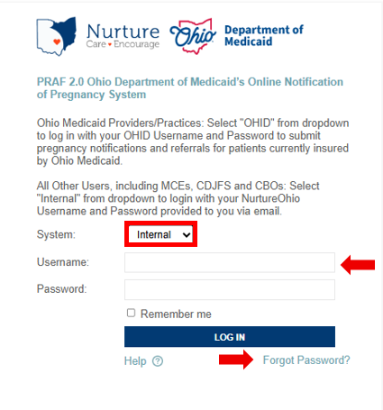
- The system will send a password reset to the user's email; user should check the spam folder for the email if it is not in their main folder.

How to Log into NurtureOhio
To access the NurtureOhio website visit: https://nurtureohio.medicaid.ohio.gov
- Select "Internal" from the dropdown list, then enter your Username and Password. Click “LOG IN.”
- Logging in allows all MCO users to submit Reports of Pregnancy for patients currently insured by Ohio Medicaid.
- Logging in allows primary MCO users to submit ROPs and review PRAF and ROP referral needs and secondary MCO users to submit ROPs.

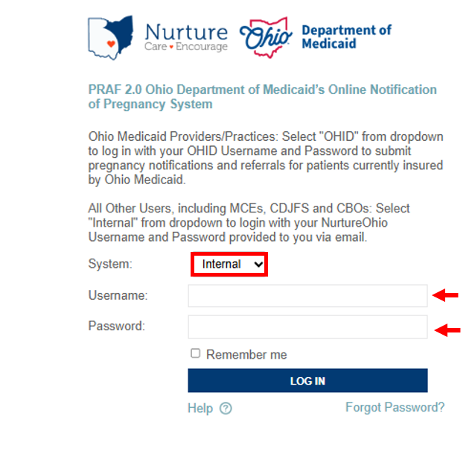

Forgotten Username or Password
If you need help logging in, contact nurtureohiosupport@deliverhealth.com.
If you have forgotten your username or password, select ‘Forgot Password?’ and enter the email associated with your user account.
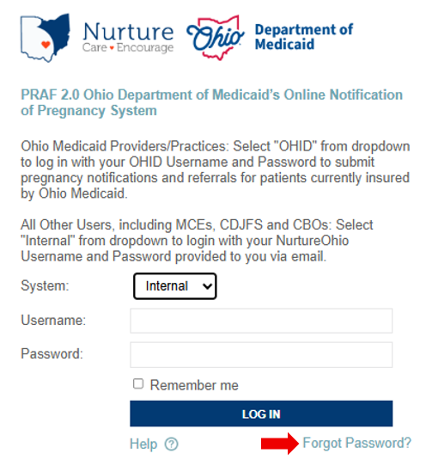

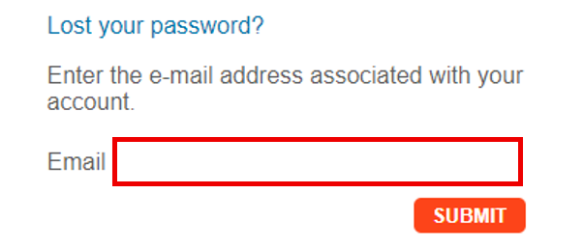

NurtureOhio Initial Profile Setup
After logging into NurtureOhio for the first time, users will be taken to “New User Profile Setup” page. Here users can update their password to something more memorable.
Once the user has updated their password, click “SAVE & BEGIN.” The user will be redirected to their welcome screen.
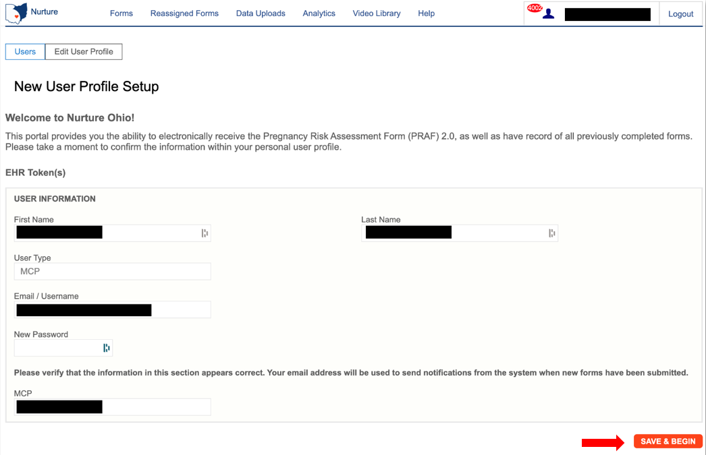

Welcome Screen
After logging in, MCO users will be taken to the Welcome Screen. The Welcome screen allows users to perform or access multiple tasks, including:
- Updating user information by clicking on the User ID
- Viewing submitted ROPs
- Viewing submitted PRAFs*
- Viewing referrals *
- Viewing reassigned forms*
- Searching for existing forms using any of the following:
- Patient Name
- Patient DOB
- Patient Medicaid transmission status
- Date of Creation (Specific date or date range)
- Date of Service (Specific date or date range)
- Viewing organization notifications
- Access to information needed to complete reports
- Downloading completed forms in PDF format or patient information in CSV format
- Exporting multiple forms at once to a CSV file
* Secondary MCO users do not have access to these functionalities
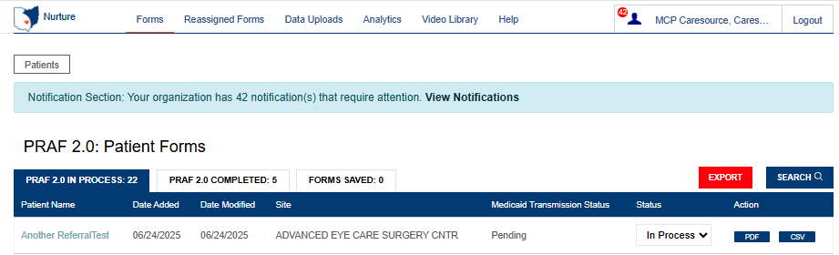

thi

Updating User Information (the Edit User Profile Screen)
After clicking on the User ID on the Welcome Screen, users can edit information about their user account. On this screen, users can:
- Edit first name and last name
- Change their password
- View user type
- Verify that their managed care plan name is correct
- Click the “Save” button to save any changes and return to the Welcome Screen. If no changes have been made, click the “Users” button at the top left of the screen
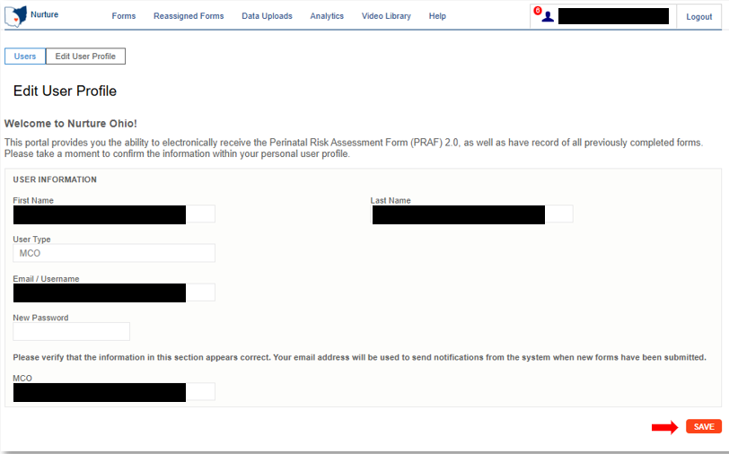
Note: Some information associated with your User ID will be inserted automatically. You will not be able to edit this information. Contact your lead to submit edits if needed for prepopulated information.
Be sure to click the “Save” button at the bottom of this screen to save any changes, or they will be lost.

How to Submit a Report of Pregnancy (ROP)
From the welcome page, the user will choose the “Forms” tab
After choosing the Forms tab, select ‘ROPs’ from the Forms menu.
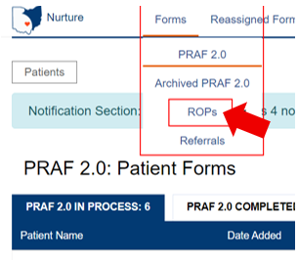
After clicking the “+ ADD ROP” button on the main ROP screen, users can begin entering information.
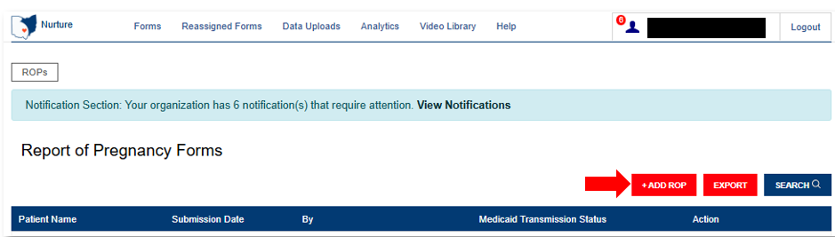

Add Patient Information

Patient Validation
To improve data quality and ensure HIPAA protections, a patient validation feature has been added to check that the information entered is linked to an individual’s Medicaid case. To complete this validation, NurtureOhio takes the information entered and searches against Ohio Medicaid’s eligibility system. The user will then receive feedback based on the data entered. If the information does not match, the user will have the opportunity to correct, re-validate, and resubmit. If the information still does not match after correcting the indicated fields, the user may continue without validation but will need to verify the data after submission, complete any necessary edits to the ROP, and then resubmit. MCO users can edit ROP information within 30 days of submission if the ROP was originally submitted by an MCO user.

Patient Validation Fields
- Complete the required fields:
  - Patient First Name
  - Patient Last Name
  - Estimated Due Date
  - Patient DOB
  - Patient Medicaid ID (MMIS number) and/or Patient Social Security Number (9-Digit)
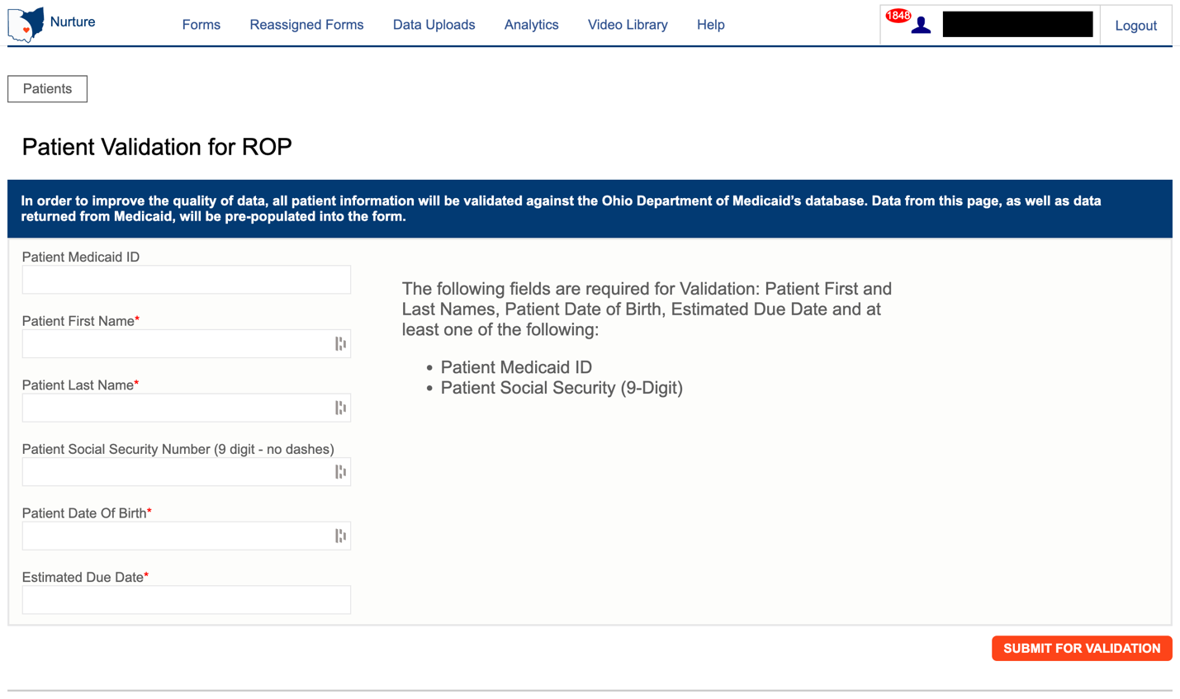
Note: The Patient's Medicaid ID may be found on the Medicaid card as shown in the graphic below. For more information and to view the Medicaid ID on archived Medicaid cards, see Appendix A.

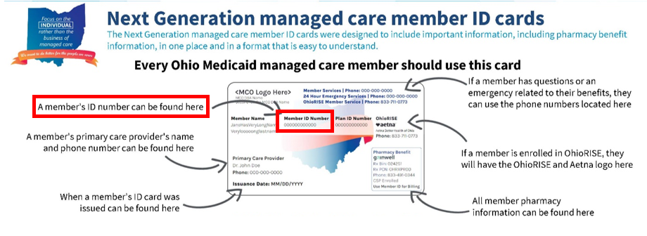

- Select “Submit for validation”
- NurtureOhio will search the ROP system to ensure no other records from the last 30 days can be found in the system for that mem
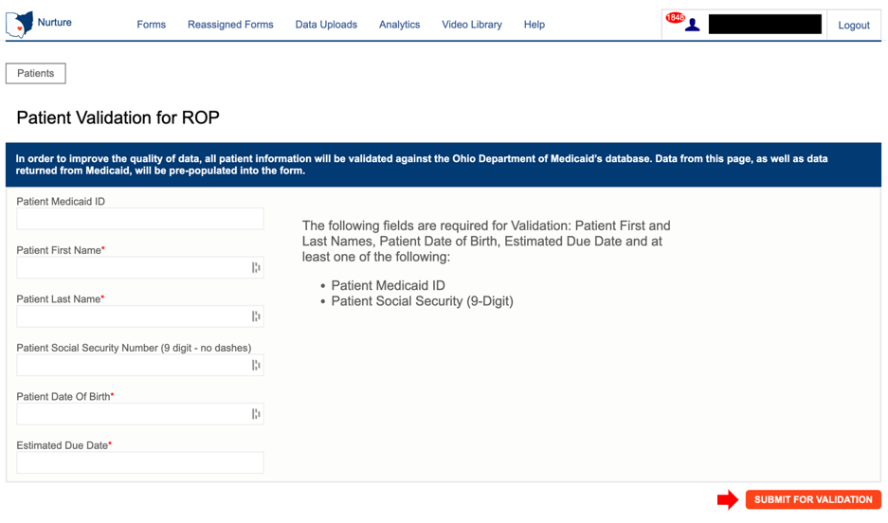

The following notification appears when you submit, select OK to proceed
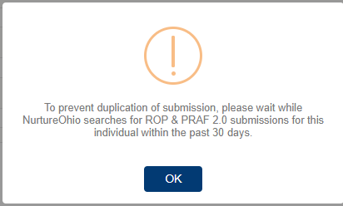

The following notification will appear if you are missing the required information
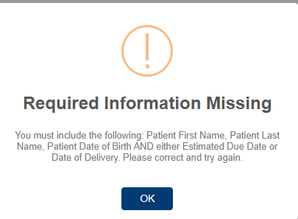
The following notification will appear when no matching ROP record is found:
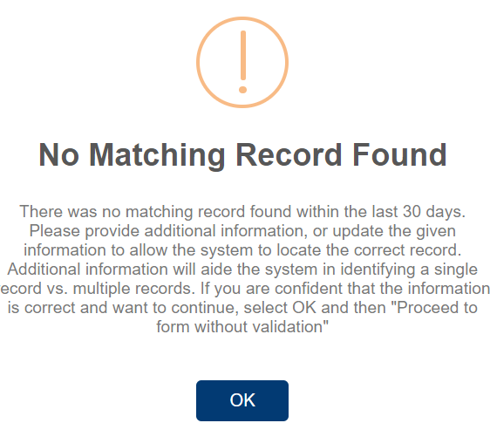

The following notification will appear when a matching record is found:
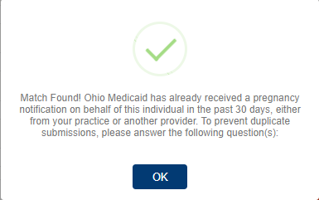

If a matching record is found, users must then answer the following questions:
In the past 30 days have there been changes to:
- The individual’s health?
- Social risk factors from the prior submission?
- If yes: the user may continue to complete a new form.
- If no: the user must open the previously completed form to edit with new information, or the user can stop the submission.
In the screenshot below, the red circled X indicates that the information provided does not have a matching record in the Medicaid system and needs to be addressed.
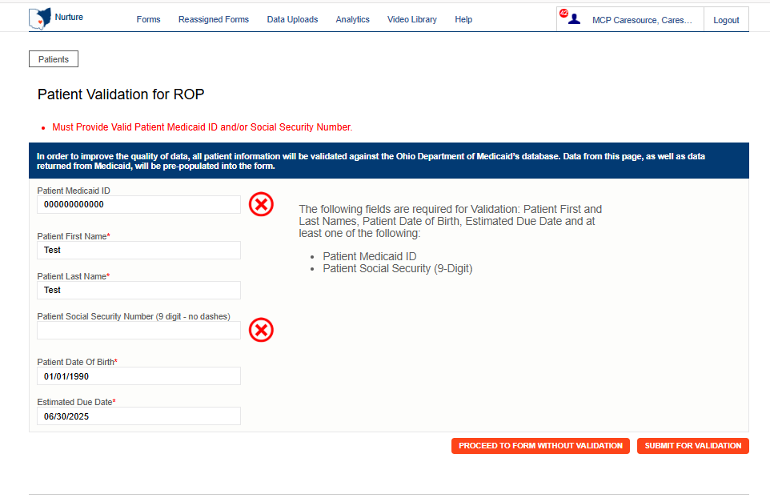

There can be multiple errors returned at once and NurtureOhio does its best to identify the fields that need to be addressed. The common errors that can be returned are as follows:

- Invalid/Missing Date(s) of Service
- Patient Date of Birth Does Not Match the Patient on File
- Invalid/Missing Patient Medicaid ID
- Invalid/Missing Patient Name
- Patient Not Found
- Duplicate Patient ID Number
- Must Provide Valid Patient Medicaid ID and/or Social Security Number
- Patient does not have active Medicaid coverage
- System is unable to respond, please contact NurtureOhio Helpdesk (This error also sends an alert to NurtureOhio)

To proceed the user must:
- Verify the patient’s information.
- Correct errors
- Resubmit for validation

In the screenshot below, the green circled check mark means the information provided has a matching Medicaid record and the user may proceed to the form.
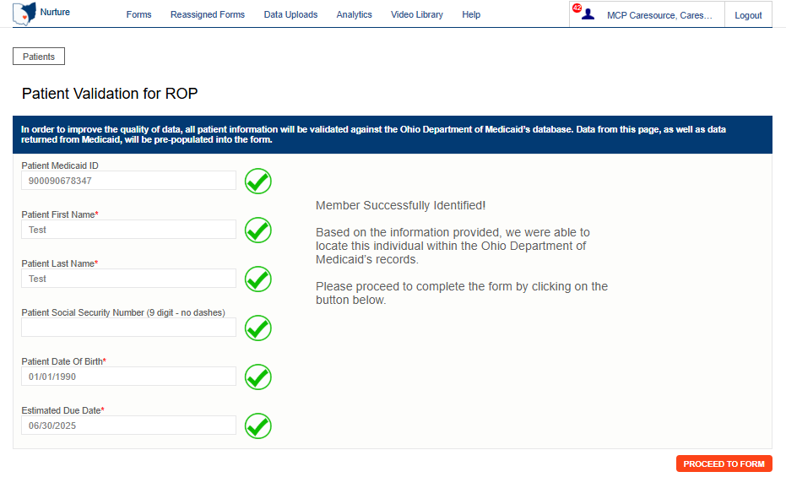

Note: The ROP can be submitted without verifying eligibility by selecting “Proceed to Form Without Verification” but please note the risks below:
- Potential HIPAA violation
    - System not notified of Medicaid eligibility

ROP Form
After clicking the “Proceed to Form” button, users are directed to the ROP Form (shown over the next few pages).
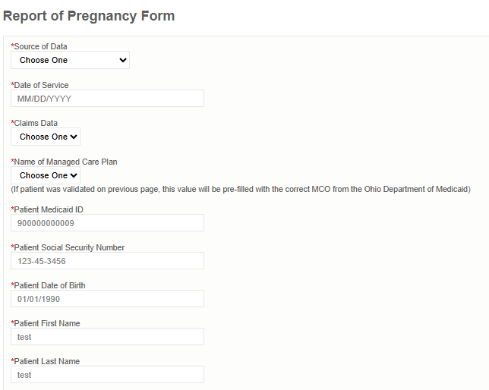
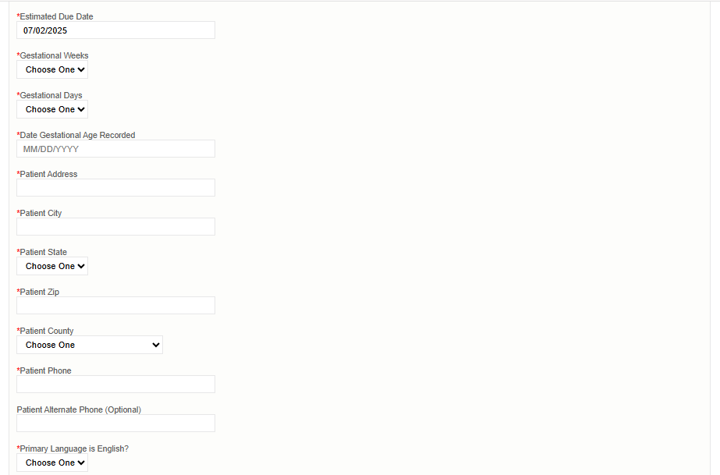

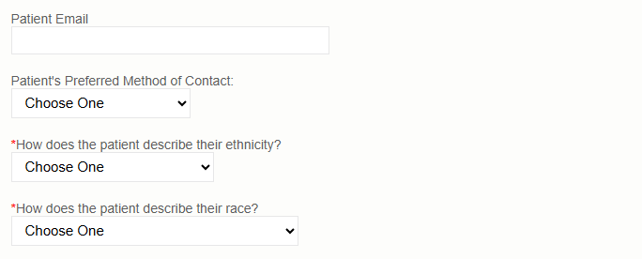

Referrals
This section is where submitters are asked to identify specific patient needs. Selecting a need will automatically trigger a referral to the patient’s Managed Care Organization (MCO) and County Department of Job and Family Services (CDJFS).
Patient need options include: Transportation; Food; Housing; Utilities; and Assistance finding an OB/GYN provider.
Submitters are prompted to indicate whether the patient:
- Assistance scheduling appointments (Yes/No)
- Patient has a prenatal appointment scheduled (Yes/No)
This information helps MCO and CDJFS staff provide appropriate support.
Submitters are prompted to indicate if the patient should be referred to WIC and/or Help Me Grow Home Visiting.
- Once the ROP is submitted, the Ohio Department of Health and the Department of Children and Youth are automatically notified if these resources are selected.

Checking “My patient would benefit from a referral for Home Visiting” will prompt you for permission to text the patient. You must ensure you have a cell phone listed for either the patient’s primary or alternate phone number listed on the form.
Once all required sections have been completed, click the “Submit” button.
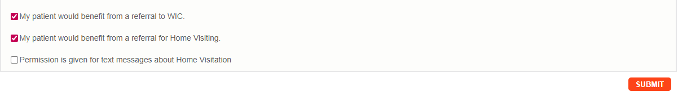

Make sure you see the “Form Completed!” message
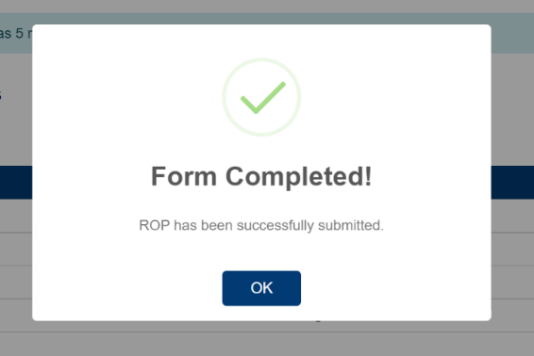
Note: If required areas are missing from the document, the user will be directed to those areas for correction or addition of information. Missing information is outlined in red.

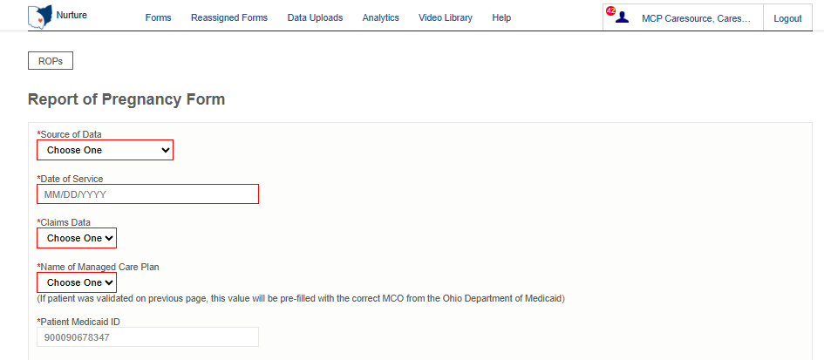
Note: If you have any general questions regarding the ROP form content or process, please email MomsandBabies@medicaid.ohio.gov with the subject ‘ROP Form’.

Processing Referrals
When filling out a PRAF or ROP, submitters can request the patient’s Managed Care Organization and County Department of Jobs and Family Services to follow up with the patient regarding a variety of needs. When needs are selected on the PRAF or ROP, a referral is created in NurtureOhio. MCOs can log into the NurtureOhio to process these referrals and report on the outcome of the referral. MCOs will determine internally which users are responsible for processing referrals for their plan.

Accessing Referrals
If an MCO user has any referrals that require attention, a ‘View Notification’ message will appear at the top of the screen. MCO users will receive a notification for new PRAF 2.0 forms, new ROP forms, and incomplete referrals.
A small red circle will also appear next to the User ID indicating how many notifications a user has.
Click ‘View Notifications’ to open a drop-down menu under the User ID. Click ‘Referrals’ on this menu to go to the Referral Reporting screen.
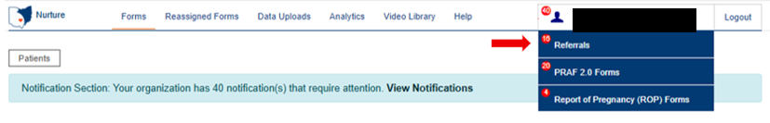
Users can also select ‘Referrals’ from the Forms menu at the top of the screen.
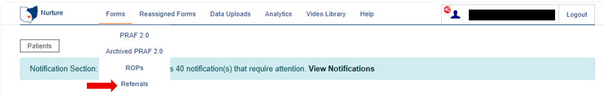

Referral Reporting Screen
The Referral Reporting screen shows referrals that have been indicated on both submitted PRAF and ROP forms. The ‘Needs’ column helps to easily identify what the member needs assistance with.
There are four tabs: Referral Requests, In Progress Referrals, Completed Referrals, and Archived Referrals.
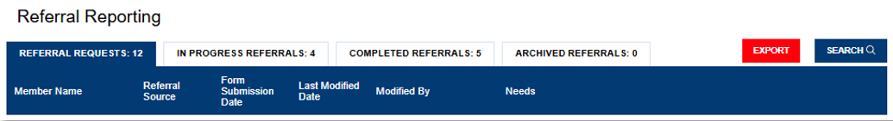

All forms will stay in the ‘Referral Requests” tab until at least one field is completed on the referral. To start processing a referral request, click on a member’s name and the ‘Referral Follow-Up Answers” screen will open. On this screen users can:
- Easily view the Patient Information to assist with patient contact.
- Click the ‘View Complete PRAF 2.0’ or ‘View Complete ROP’ button to view the patient’s submitted PRAF or ROP.
- View needs that have been indicated on the PRAF or ROP for referral.
- Provide information regarding the outcome of the referral.
- Add additional needs for referral that have not already been identified.
Below is the Patient Information displayed on a referral created from a PRAF submission. Fields displayed include: Name; Date of Birth; Medicaid ID; Phone; Email; Language; County; WIC Referral (Y/N); Home Visiting Referral (Y/N).

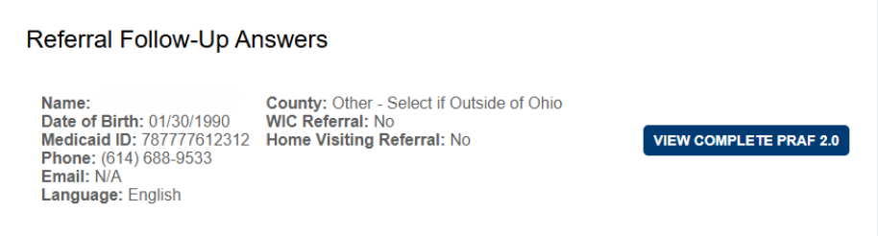

Below is the Patient Information displayed on a referral created from an ROP submission. Fields displayed include: Name; Date of Birth; Medicaid ID; Phone; Email; Language; County; WIC Referral (Y/N); Home Visiting Referral (Y/N); Prenatal Visit Scheduled (Date); Assistance Scheduling Appointments (Y/N).

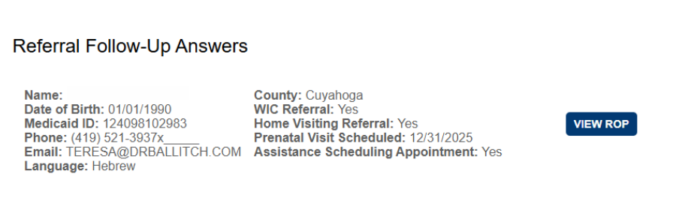
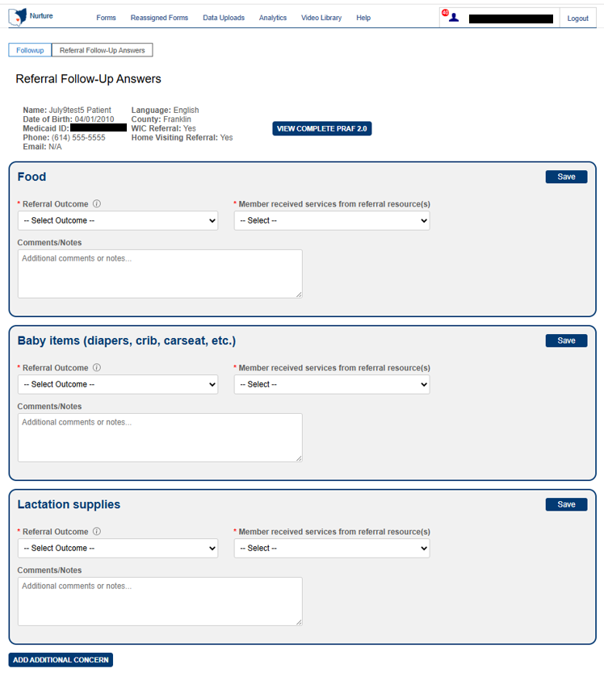

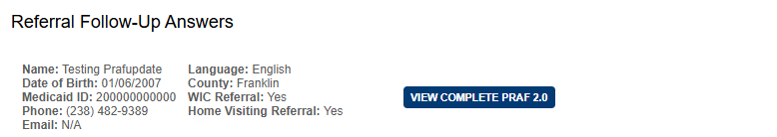

Tooltips provide additional information. Hover over the tooltip to open it.

To process a referral, select an answer from each drop-down menu for each need. Complete all required fields and when finished, click “Save.”
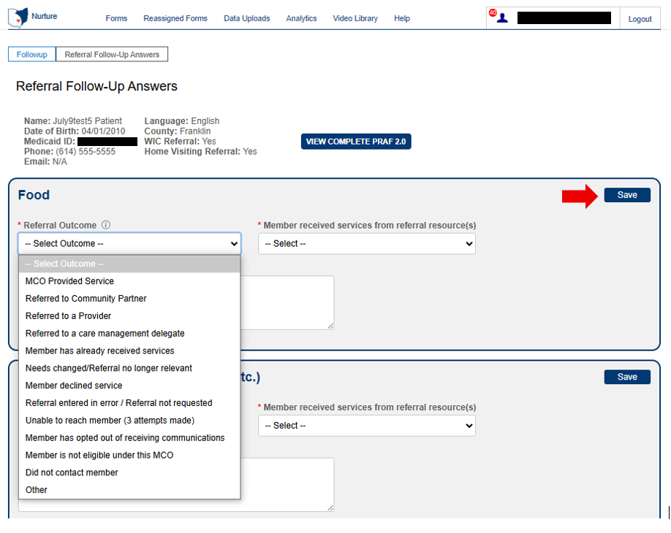

Note: Users can enter information in the ‘Comments/Notes’ field to provide additional information about the member or take progress notes. This field is not required. Entering information in the ‘Comments/Notes’ field does not change the status (Example: Referral Requests/In Progress Referrals/Completed) of the referral. Click ‘Save’ after entering information in the ‘Comments/Notes’ field to save your data.
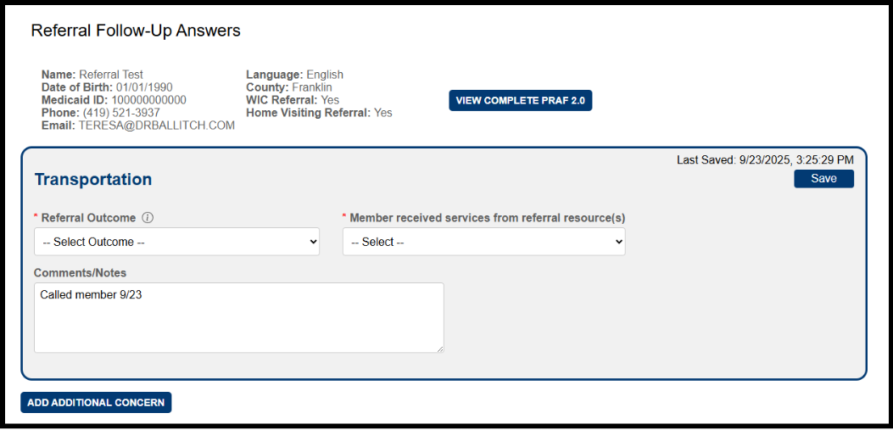

Note: You must click the “Save” button on each individual need in order to save your progress. You can edit or change notes after you have saved if necessary.
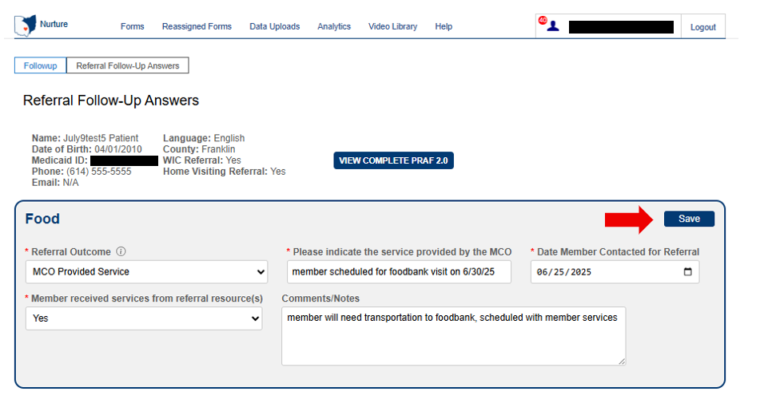

After referrals are saved, you will see a “Last Saved” date and time. This will help users to keep track of the action taken on referrals.
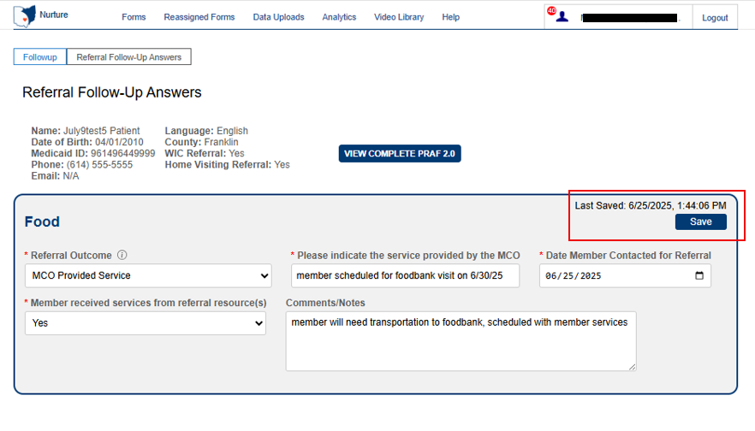

If any concerns still require completion, the referral will move to the “In Progress Referrals” tab. Referrals can be edited under this tab.
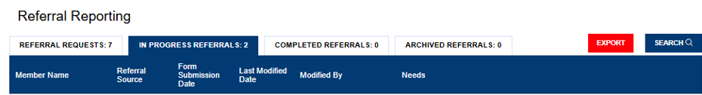

If all concerns are addressed and saved the referral will move to the “Completed Referrals” tab. Referrals can be edited under this tab.
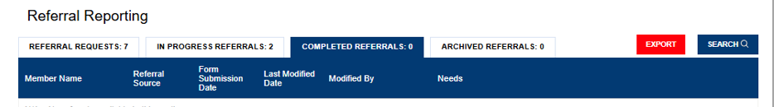

All completed referrals will move to the “Archived Referrals” tab after 365 days of completion.
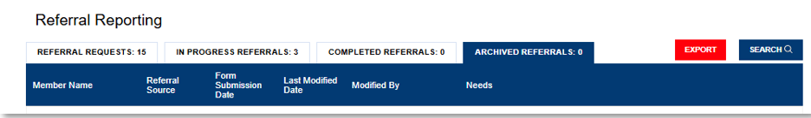

Adding Additional Concerns
Users can add additional needs not identified on the PRAF or ROP for referral. For instance, an additional concern may be added for a patient who has already had a PRAF or ROP submitted but later found to have a previously unidentified risk factor or referral service/need.
For PRAF referrals, additional concerns that can be added are:
- Transportation
- Food
- Housing
- Utilities
- Interpersonal violence/Safety
- Employment
- Education
- Finding a behavioral health provider
- Finding a primary care provider
- Finding a pediatrician
- Baby items (diapers, crib, carseat, etc.)
- Connection to lactation consulting
- Lactation supplies
- Connection to tobacco cessation services
- Connection to substance use disorder services
- Connection to alcohol-related services
- Connection to opioid use services
For ROP referrals, additional concerns that can be added are:
- Transportation
- Food
- Housing
- Utilities
- Finding an OB/GYN provider

The ‘New Referral Follow-Up’ screen will open, allowing you to add a referral.
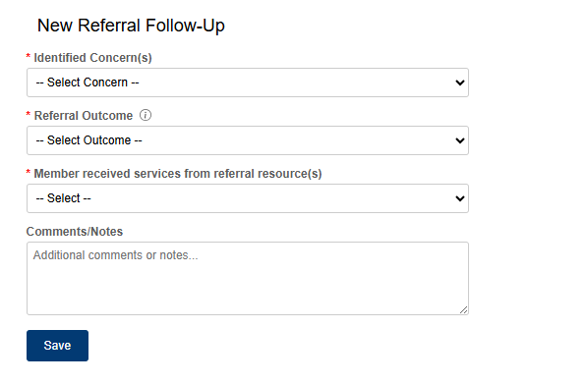
Select the additional identified concern from the dropdown to create a new needs referral item.
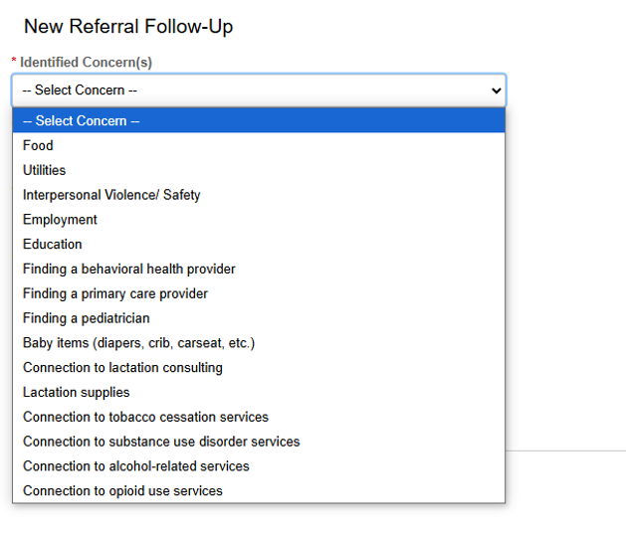

Once submitted, the new concern will appear on the referral screen.
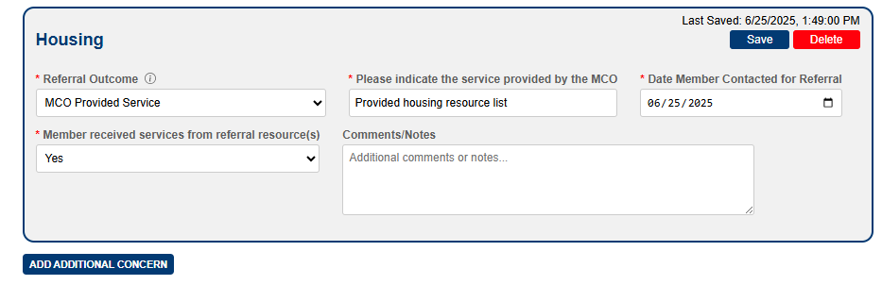
Note: Users will only have the option to delete manually added additional concerns. All concerns submitted via the PRAF and ROP will need to be completed.

Exporting

Exporting Referrals
The Export option allows you to export all referrals associated with the logged-in MCO user to a CSV file. Click the Export button at the top of the Referral Reporting screen next to the search button.
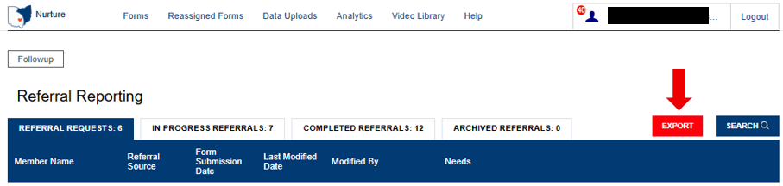
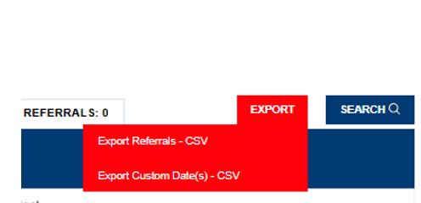
The dropdown menu will provide you with export options for referrals. Once you select an option, the file will be exported and saved to the default download folder on your local machine.

Exporting ROPs
The Export option allows you to export all forms associated with the logged-in MCO user to a CSV file.
Click the Export button next to the search button.
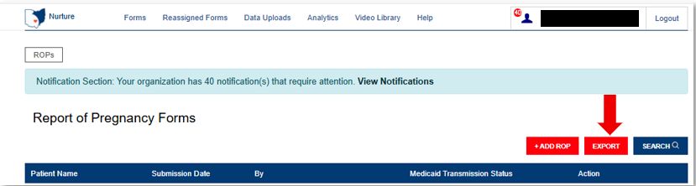
The dropdown menu will provide you with export options for ROPs. There is also an option for exporting the NurtureOhio Data Dictionary. This document describes the details of the file output. Once you select an option, the file will be exported and saved to the default download folder on your local machine.
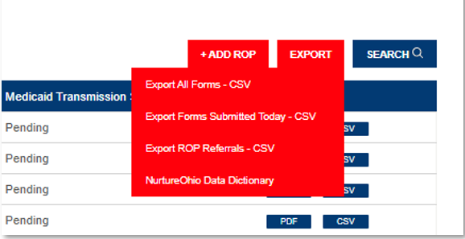

Exporting PRAFs
Users can export multiple PRAF forms to a CSV file by clicking the EXPORT button on the main forms screen.

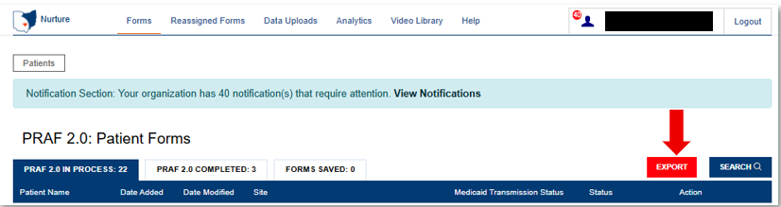

The dropdown menu will provide you with export options for PRAFs. There is also an option for exporting the NurtureOhio Data Dictionary. This document describes the details of the file output. Once you select an option, the file will be exported and saved to the default download folder on your local machine.
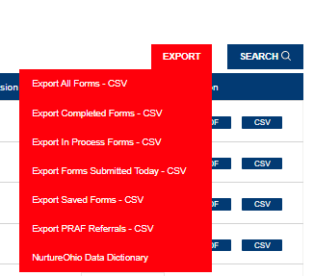

Log Out
It is important to log out of the NurtureOhio system when finished.
- Select “Logout” in the top right-hand corner of the screen.

Help Desk and User Support
If you have any concerns or issues with the website or are unable to view fields, please use the “Help” button shown in the screenshot below.
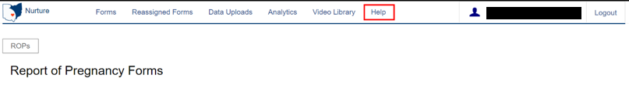

Help Form
You will then want to describe the issue that you are experiencing in the text box. Include a contact email and then click ‘Submit.
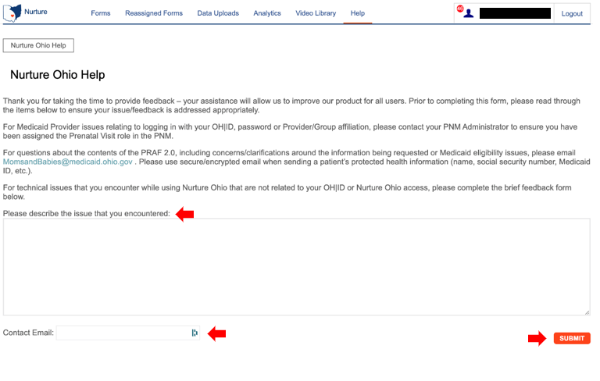

Maintenance and System Outages
If the NurtureOhio system is shut down for maintenance, you will receive an e-mail from the Nurture Helpdesk (no-reply@duethealth.com). The Ohio Department of Medicaid paper-based notification process can be used during these system outages. The paper-based form, ODM 102577, and its accompanying instructions, ODM 102577, can be found at the URL below.
http://medicaid.ohio.gov/RESOURCES/PUBLICATIONS/MEDICAIDFORMS.ASPX

Appendix A

About NurtureOhio Features

Shareable Data Entry
Users can edit a ROP form submitted by themselves or another MCO user at their organization up to 30 days after the original submission date.

Same-Day Pregnancy Notification
Pregnancy notification helps patients maintain Medicaid eligibility. It also helps MCOs address the needs of pregnant Medicaid members more quickly.
The NurtureOhio website can notify the managed care plan and the Ohio Benefits Worker Portal of the patient’s pregnancy the same day it is entered into NurtureOhio. Practice users assist in this process by accurately entering the following patient information:
- First name
- Last name
- Date of birth
- Social security number (full nine digits)
- Medicaid ID/MCID
Ohio Benefits, Medicaid’s eligibility system, accepts pregnancy information directly from the information users enter NurtureOhio. Accuracy of the five details above is important to match the individual’s case in Ohio Benefits. The member ID displayed on the patient’s Medicaid card and/or the patient’s social security number is important as they are used to identify the member for whom pregnancy needs to be updated. The estimated pregnancy due date paired with the latter five identifiers are used to update the Ohio Benefits system. This helps prevent loss of coverage during pregnancy.
Please note the member ID number is consistent across Medicaid MCOs; however, the member ID number will not always be the same as the MCO ID #, which varies by insurance plan. Thus, please be sure to capture the member ID number and not mistakenly input the MCO ID #.
The member ID # is:
  - Used to verify a patient’s eligibility and their MCO,
  - Consistent across all MCOs and Ohio Medicaid, and
  - Required for the PRAF 2.0 form to communicate with Ohio Benefits.

Below is where you will locate the member ID number on our contracted managed care entity insurance cards.

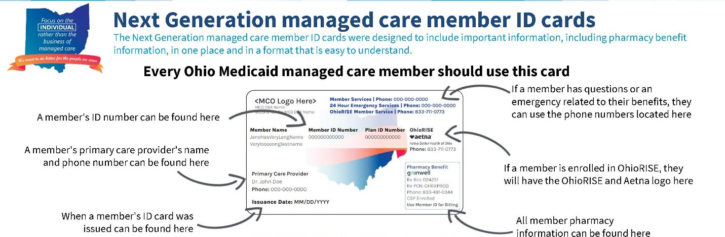


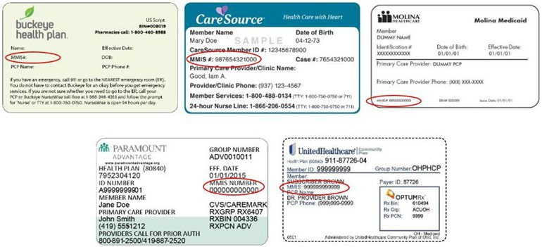
Below is where you will locate the member ID number on archived versions of the managed care organization cards.

Ability to Retrieve and Save Previously Entered Forms
Forms entered can be viewed and downloaded in two different formats (PDF and CSV).
- Navigate to the “Forms” tab
- Select ROPs or PRAF 2.0 depending on what type of form you are trying to retrieve
- After making your selection you can choose PDF or CSV under the Action heading to view or download forms

